**Topic Name:**

The main aim of this lab session is to provide hands-on experience on

* Getting Help
* Basic Commands
* Navigation
* File System
* simple shell script

1. Getting Help

|  |  |  |  |  |
| --- | --- | --- | --- | --- |
| Task | Command Name | Syntax | Example | Screenshots |
| To get manual page for the known command | man | man cmd_name | man rm |  |
| To get manual page for the unknown command | which | which cmd_name | which ls |  |
| To know the source file binary | whereis | whereis command_name | whereis mv |  |
| To know the path of the command | which | which command_name | which mv |  |
| To know the command is external or internal | type | type command_name | type rm,  type echo |  |

1. **Basic Commands**

|  |  |  |  |  |
| --- | --- | --- | --- | --- |
| Task | Command Name | Syntax | Example | Screenshots |
| To know today’s date | date | date | date |  |
| To print calendar | ncal | ncal | ncal |  |
| To print kernel version | cat | cat version_file_path | cat /proc/version |  |
| To print default shell | echo | echo $SHELL | echo $SHELL |  |
| To print currently logged in user | whoami | whoami | whoami |  |
| To create shortcut for command | alias | Alias short_name = value | Alias ll =’ls -la’ |  |
| To delete shortcut | unalias | Unalias short_name | unalias ll |  |
| To change the timestamp of the file | touch | touch -t YYYYMMDDHHMM.SS filename | touch -t 202408011010 filetest |  |
| To clear the screen | clear | clear | clear |  |
| To create empty files | touch | touch filename | touch filename.txt |  |
| To know disk usage | df | df -option | df -h |  |
| To know free space in the system | df | df -option | df -h |  |
| To know about the Linux release | lsb_release | lsb_release –[option] | lsb_release -a |  |

1. **Navigation**

|  |  |  |  |
| --- | --- | --- | --- |
| Task | Command | Syntax | Screenshots |
| To navigate home directory | cd | cd |  |
| To navigate to the parent directory | cd .. | cd .. |  |
| To navigate to the child directory | cd | cd filename/directory_name |  |
| Alternate command to cd | pushd | pushd path |  |
| To go back to the previous directory | cd - | cd - |  |
| To go to the root directory | cd / | cd / | 2 |

1. **File System**

|  |  |  |
| --- | --- | --- |
| **Task** | **Syntax** | **Command** |
| **How to identify the file system** | lsblk | lsblk -f |

1. Create Folder “CYS”
2. Navigate to CYS

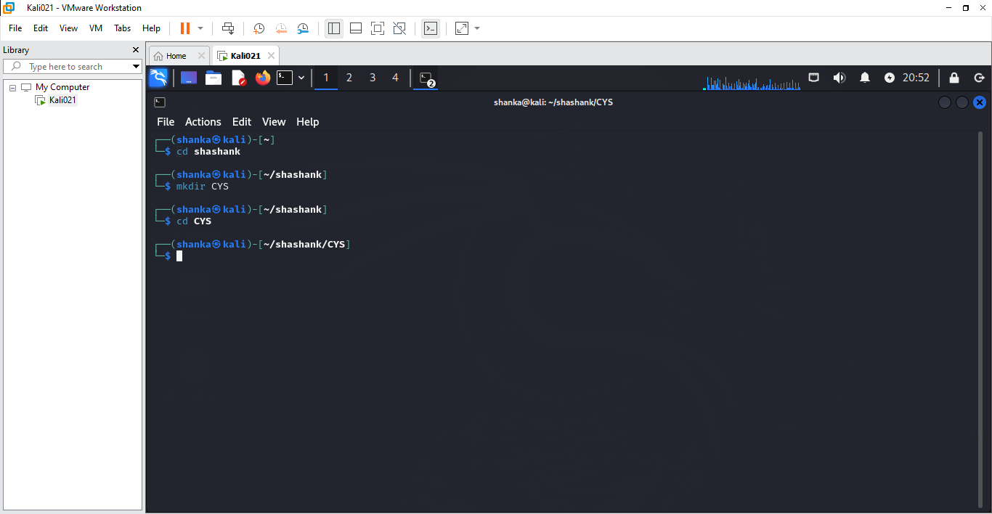

1. Create folder LS1 and LS2 under CYS

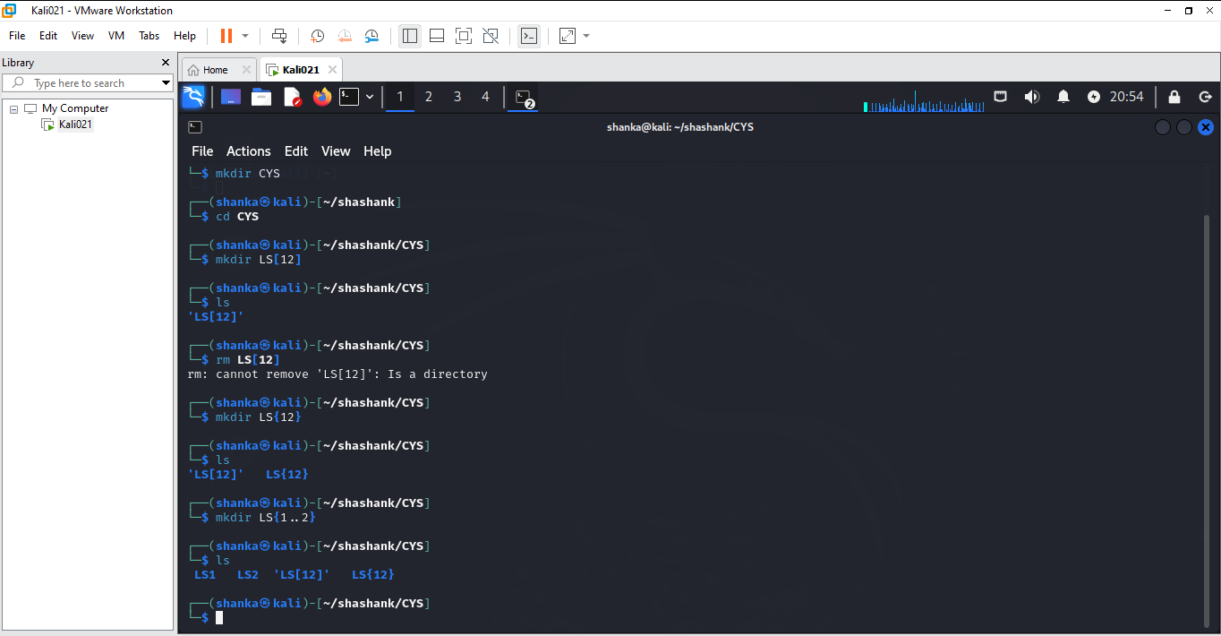

1. Go back to CYS

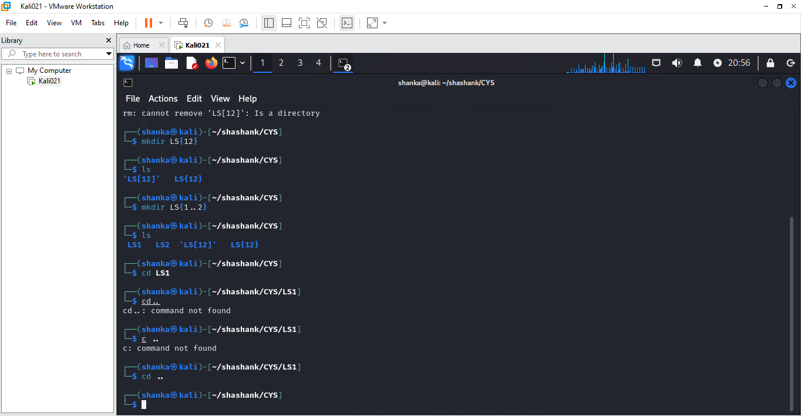

1. Working with Files
2. Add commands which you learnt during lab session in the file commands.txt

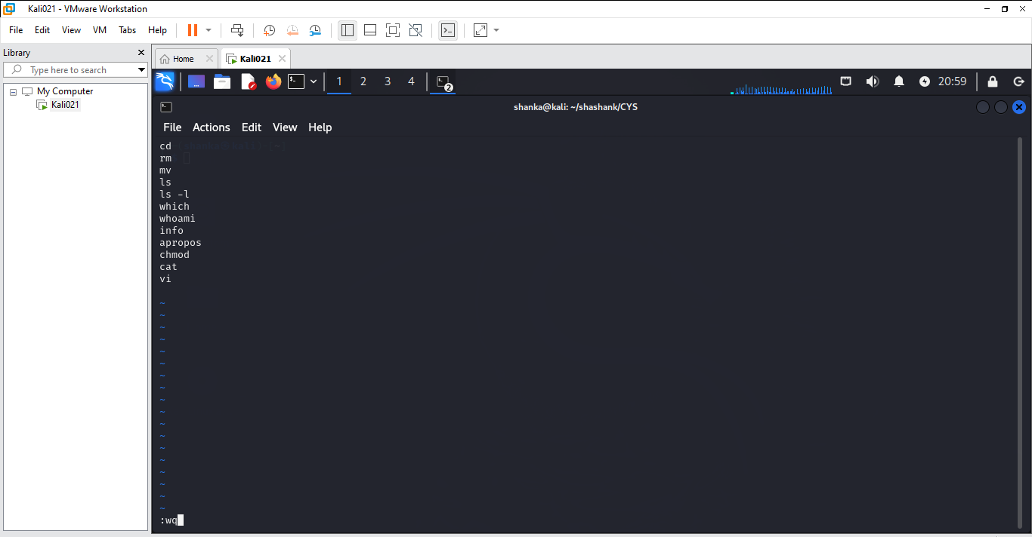

1. Change the timestamp of the file to yesterday

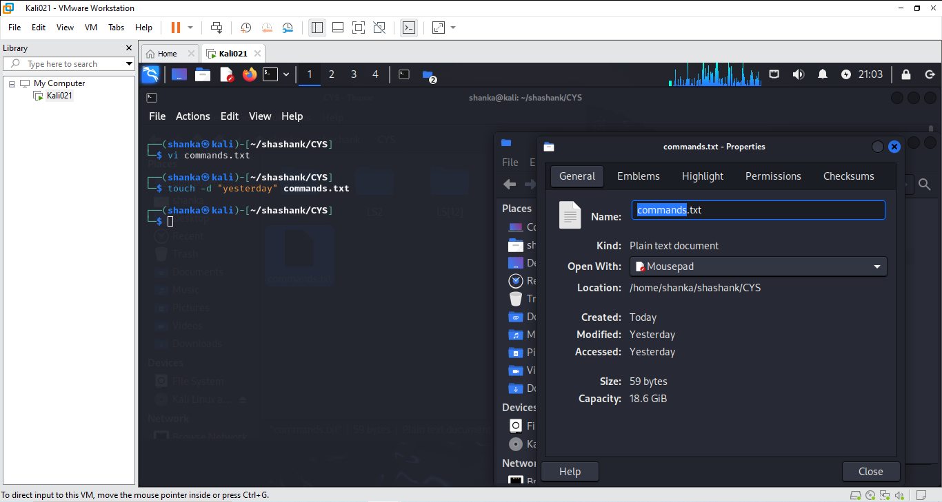

1. Copy the contents from the file commands.txt to commands_demo.txt

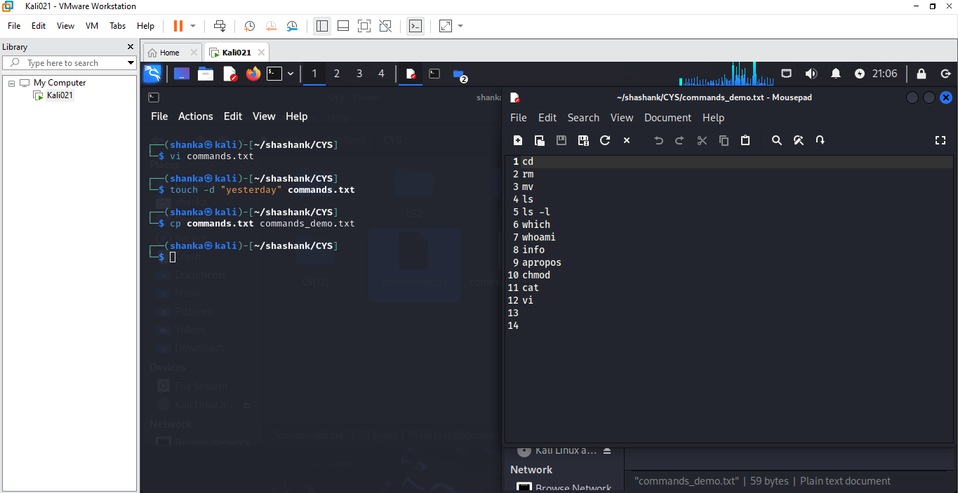

1. Rename the file commands_demo.txt to duplicate

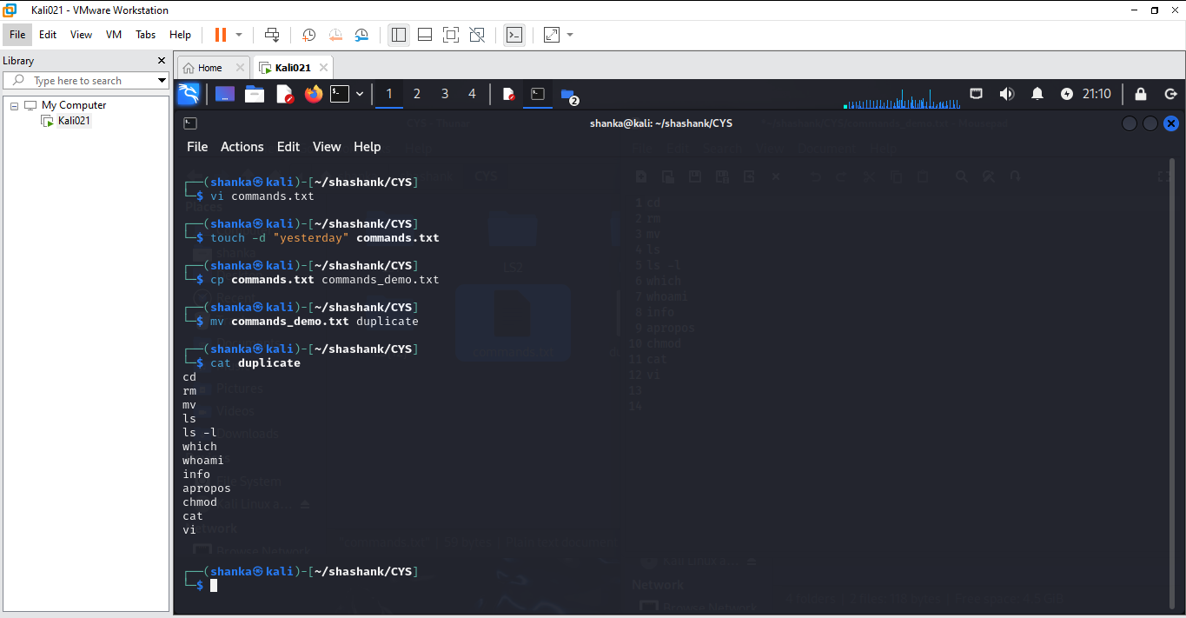

1. Rename all .html to .hldd

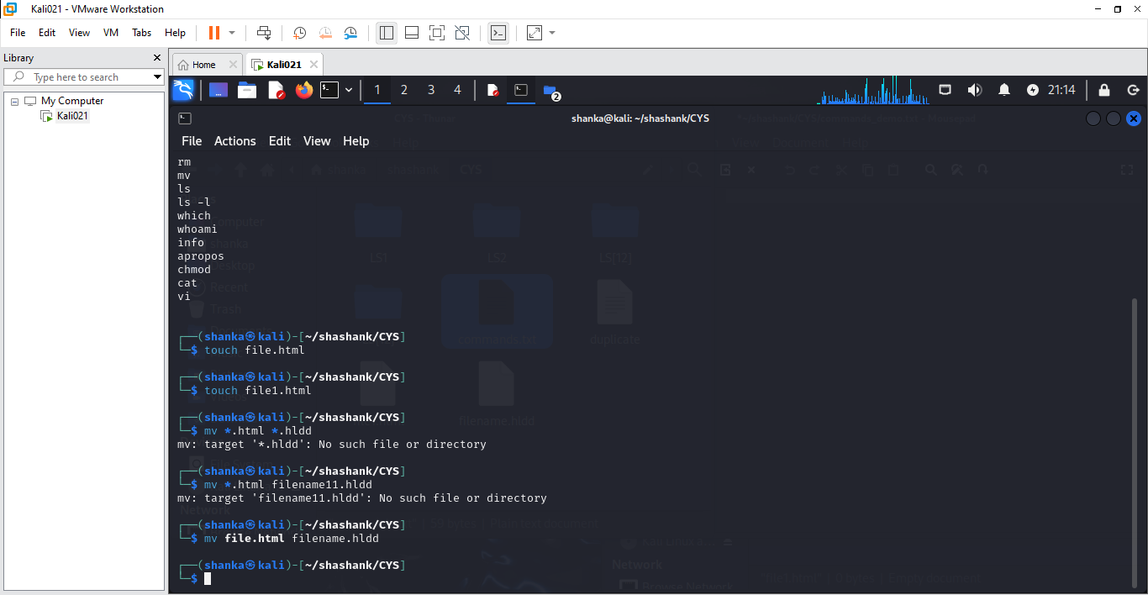

1. Delete the file duplicate

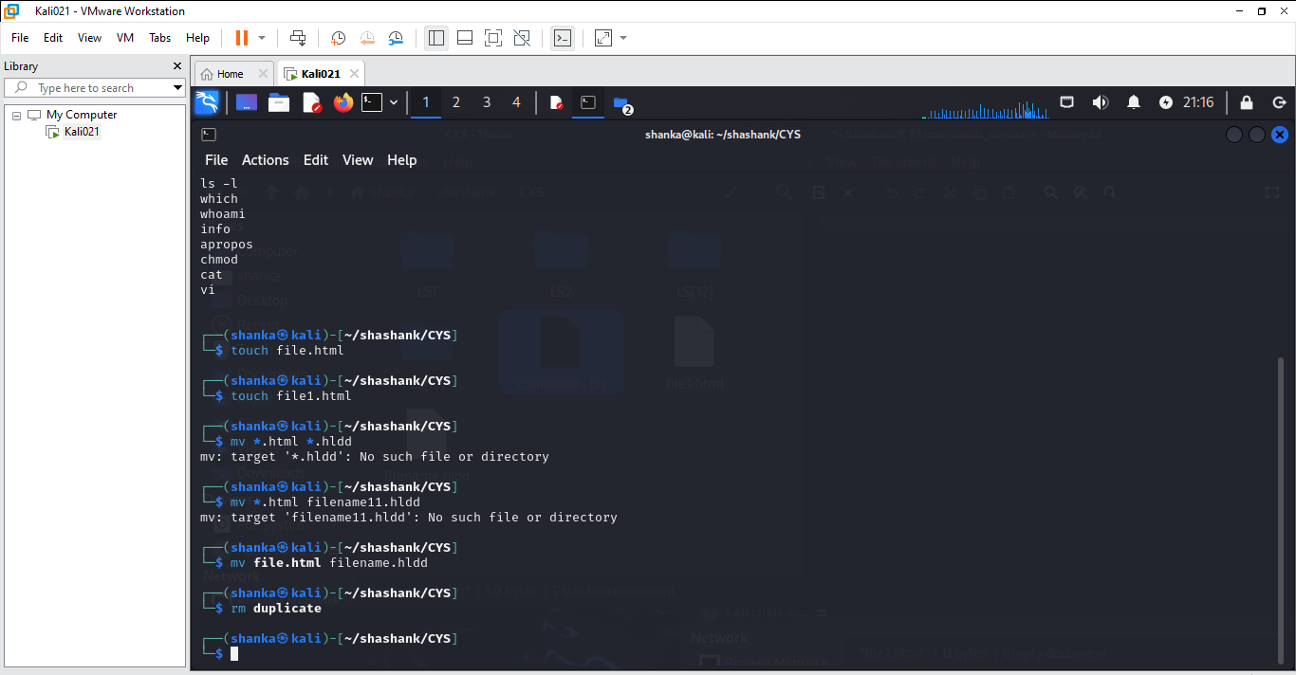

1. Copy the contents commands.txt to unit4 and unit5 (using relative path)

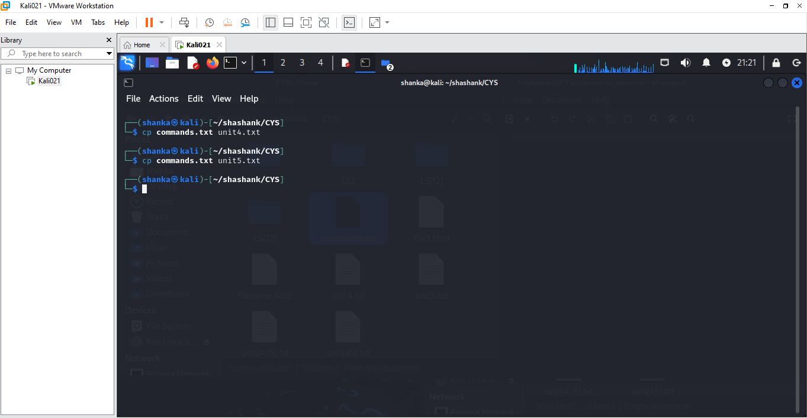

1. Delete the contents from unit5 (using absolute path)

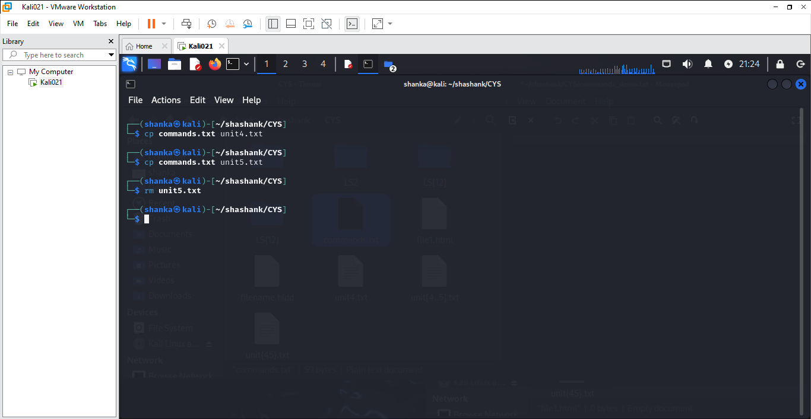

1. Navigate to root

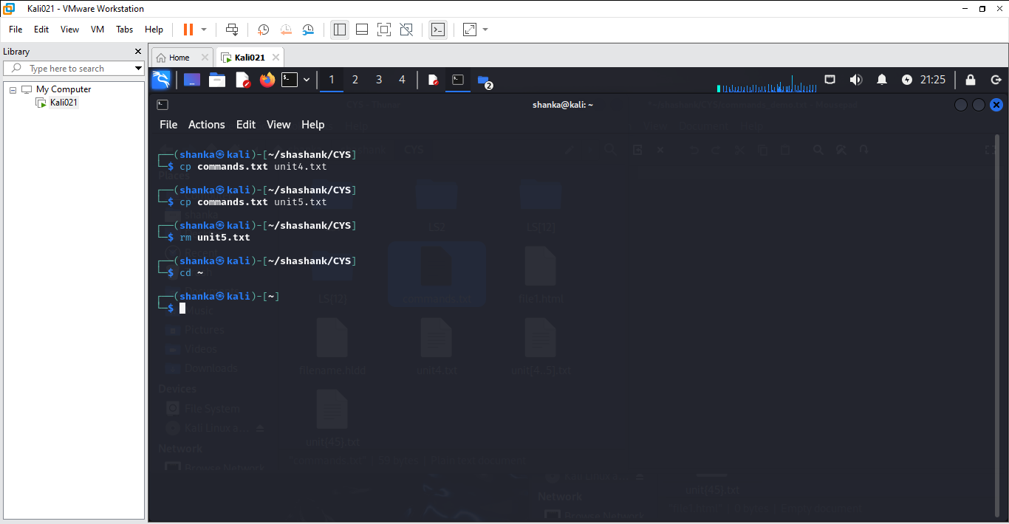

1. List all the files under root

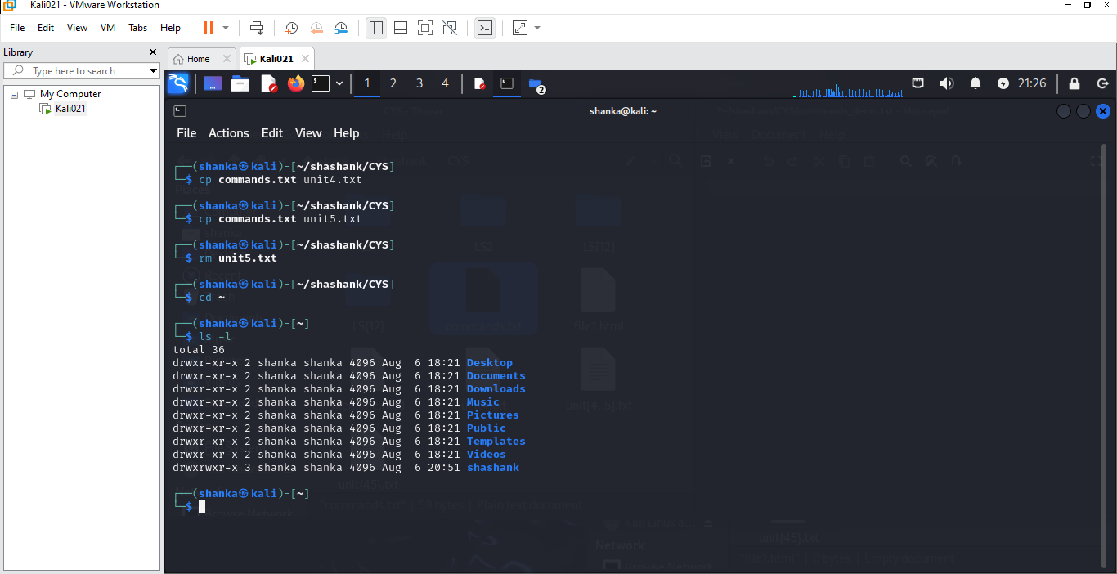

1. Explore all the folders (Do not delete any folder)

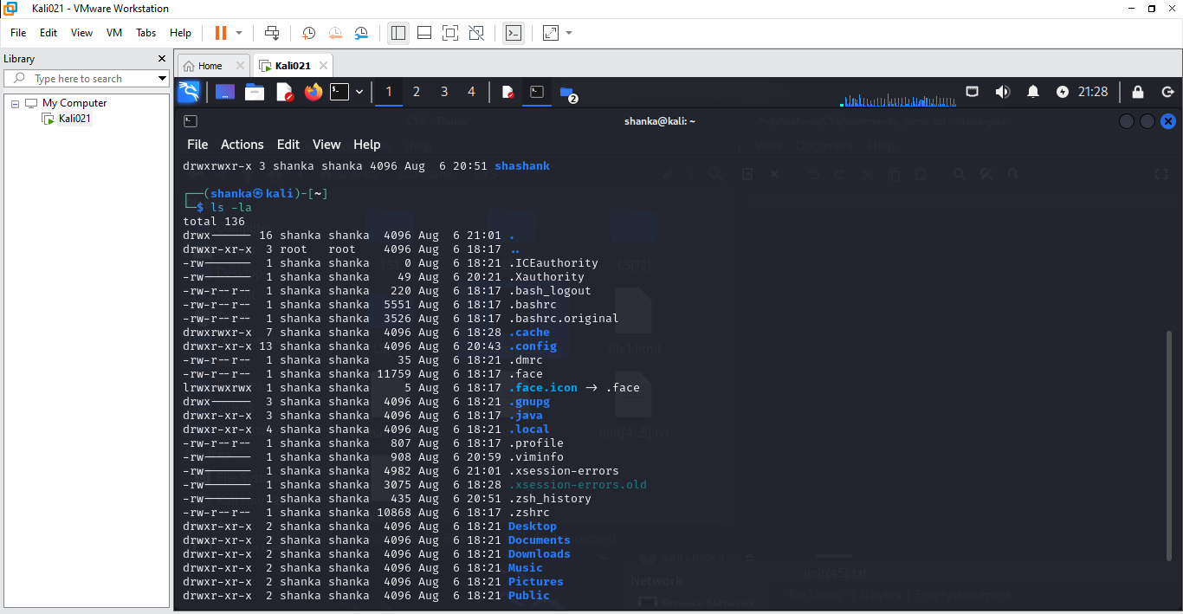

1. Navigate to /etc/passwd

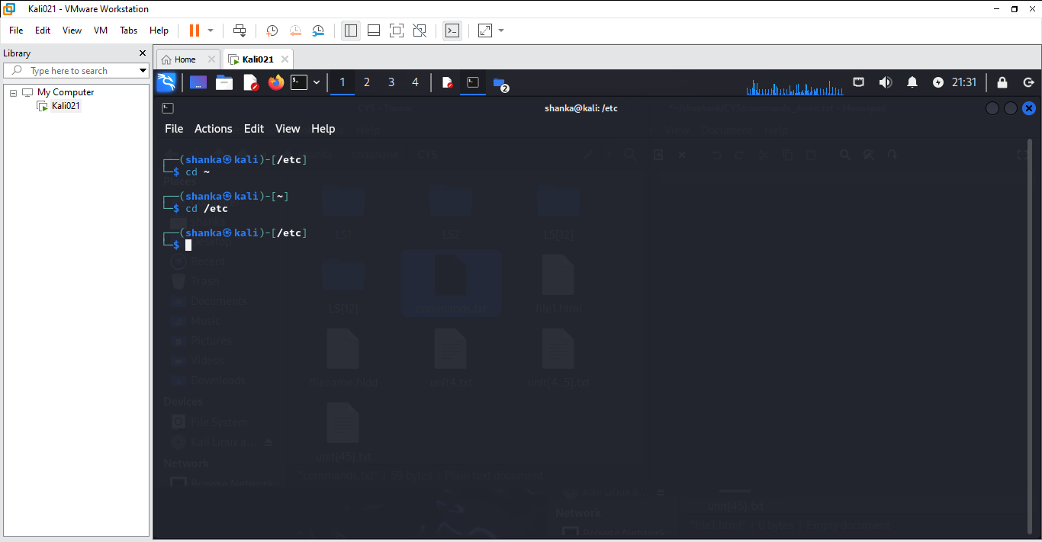

1. Open the file passwd

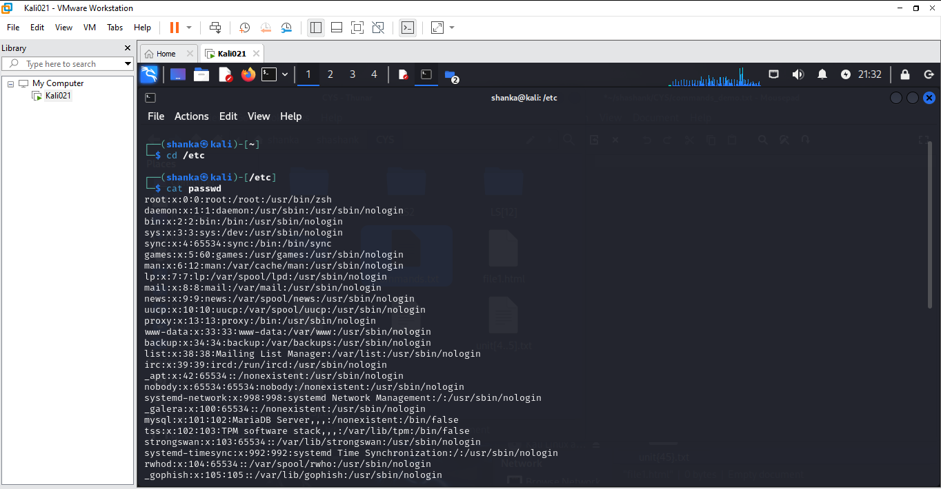

1. Explore the file passwd

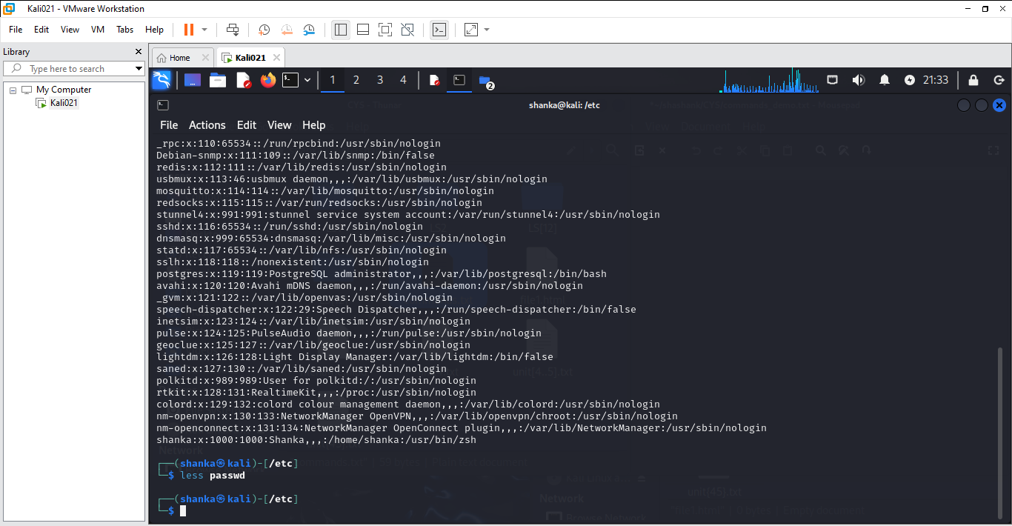

1. Navigate to /etc/group and explore

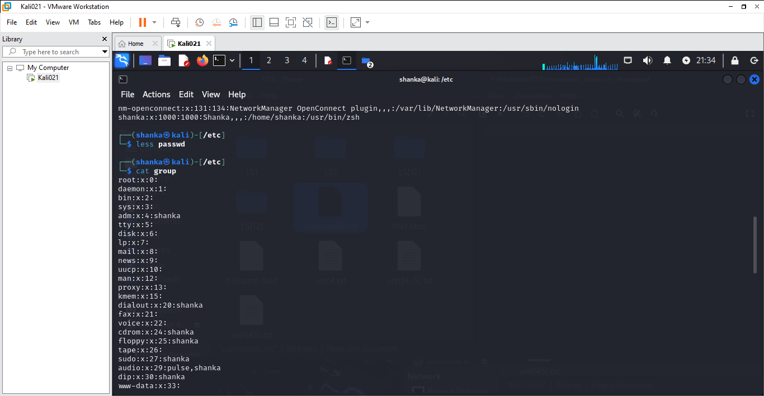

1. **Difference between** 
   * + 1. GUI vs. CLI

* GUI stands for **Graphical User Interface**. A GUI enables users to interact with the operating system or application. GUI offers buttons, windows, scrollbars, iconic images, wizards, and other icons to facilitate users. It has a user-friendly interface for beginners. It is easy to use, learn and also reduces the cognitive load. Unlike CLI users, GUI users do not need to remember commands; rather, they have to be able to recognize them and perform good exploratory analysis and graphics.
* A CLI is an interface that allows the user to perform tasks by issuing commands in successive lines of text or command lines.
  + - 1. man vs info
* **man** is a system-wide documentation system that provides short reference manuals (pages) for individual commands, API functions, concepts, configuration file syntax, file formats organised in sections (1 for user commands, 2 for system calls...). That's the traditional Unix documentation system.
* **info** is another documentation system originating in the GNU project. It's hypertext with links (predates the web). An info manual is like a digital book with a concept of table of contents and (searchable) index which helps locating the information.
  + - 1. which vs. whereis
* The **which** command is used to **locate the executable files** or location of a program from the file system. It displays the path where the specified file or command is stored.
* The **whereis** command locates the source, binary, and manuals sections for specified files.
  + - 1. Terminal vs shell
* A program that provides a user interface to interact with a computer system through text-based input and output.
* A command interpreter program that enables users to interact with an operating system, executing commands and scripts.

1. Write a simple shell script to print your name and your hobbies!

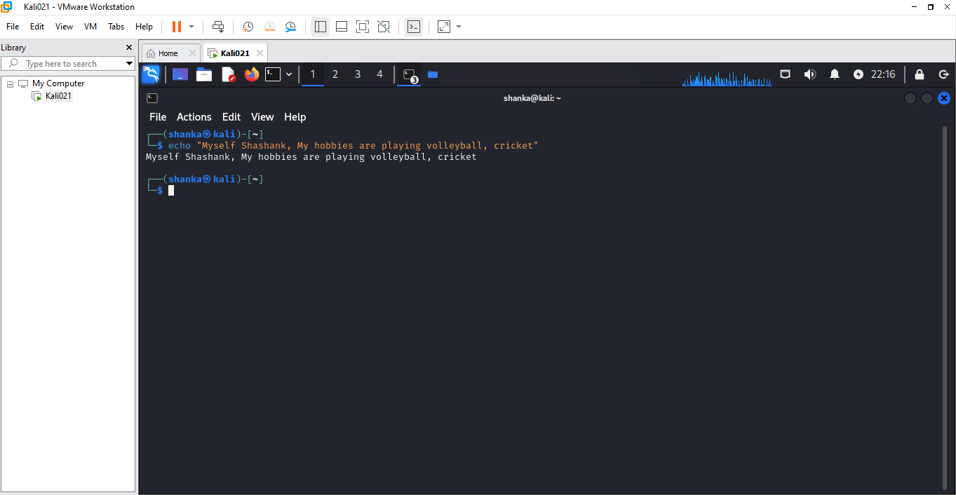

**Note:** Include your screenshots

Evaluation :

Marks : 10 (Deadline : 4 – Originality :3 – Completeness :3 )

Deadline: 06.08.2024

“All our dreams can come true if we have the courage to pursue them.”

Walt Disney